**Purchase an AT&T IOT Data Plan and SIM** [https://marketplace.att.com/products?tags=connectivity](https://nam02.safelinks.protection.outlook.com/?url=https%3A%2F%2Flists.gonzaga.edu%2Fdada%2Fmail.cgi%2Fr%2FPCICOMPLIANCE%2F022844226678%2F&data=02%7C01%7Cjaube%40middlebury.edu%7C15fe4591a1ad4c4ab9fc08d719e40eda%7Ca1bb0a191576421dbe93b3a7d4b6dcaa%7C1%7C0%7C637006339608290178&sdata=4Oa6DInY9iO%2F8bOld%2Fs31poPevSF51WEn56Uxf87zck%3D&reserved=0)

**Installing an AT&T IOT SIM card**

*Sim Card Requirements:*

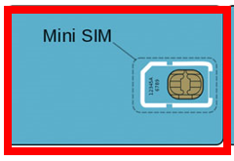

1. Turn off the terminal. Turn the terminal over and remove the battery cover plate. To remove the battery cover plate, slide the switch to the right. Lift the cover from the bottom and then pull up.
2. Remove the battery. Lift the battery from the bottom upwards and towards the bottom and pull out.
3. SIM card installation. After the battery is removed the SIM card should be installed in the TF SIMCARD slot location on the device. It should be labeled SIM1 or SIM Card Slot 1.

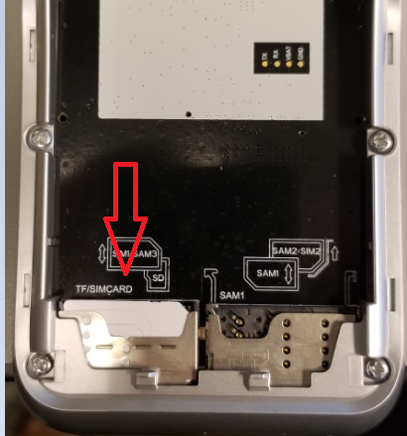

1. Reinsert the battery
2. Replace the battery cover. Please be sure to slide the switch to the left to lock the battery cover in place.

**Setting Up Cellular Data in PAX A920**

1. After the SIM card has successfully been installed into the device. The device should show this screen

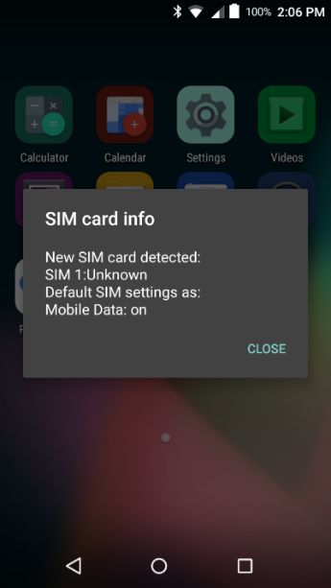

*(Note: If device has already had a SIM installed, device will not show “Detected new SIM Card Info”, device will automatically connect SIM card)*

1. From the Home screen select the settings icon.

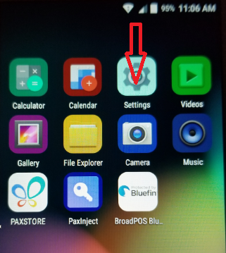

1. The terminal will prompt for a Password. Enter **9876** and select OK.

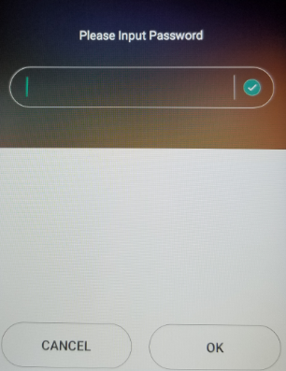

1. The Setting menu will appear. Select the More button.

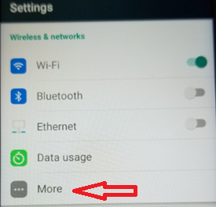

1. The More menu will appear. Select Cellular Networks.

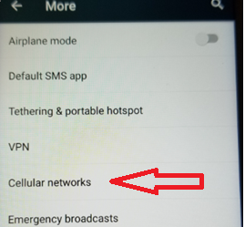

1. The Cellular Network menu will appear. Enable Data enable and Data roaming, disable Use preferred APN. Select Access Point Names.

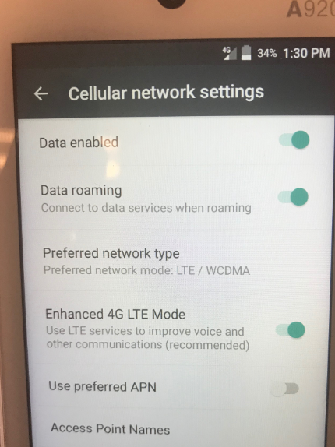

1. Select the  to add an APN

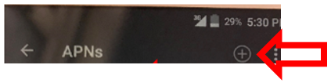

1. Edit access point
   1. Name: att portal
   2. APN: m2m.com.attz
   3. Leave the rest of the configurations as is:
   4. Proxy, Port, Username, Password, Server, APN protocol, APN roaming protocol, save

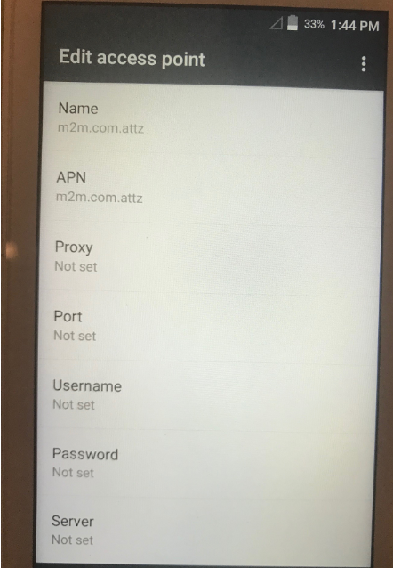

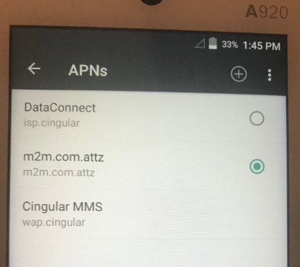

1. Unselect Use preferred APN
2. Navigate back to Home Screen; you should see the 4G icon.
3. Test a transaction using cellular only (disable the Wifi, as the device will prioritize Wifi over cellular). Perform a test transaction. If successful, void the transaction and turn Wifi back on. 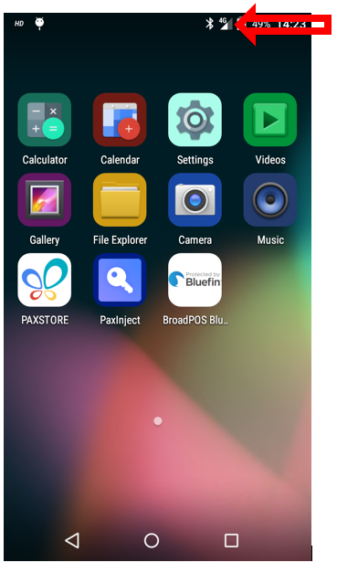

**Mobile Troubleshooting:**

Validate Part number is A920-2AW-RD5-11EA

To find IMEI #: Settings/About Device/Status

**How to confirm if a terminal has a mobile signal.**

1. At the top of the screen check for bars. **Turn off wifi**, open BroadPOS app and try a test sale

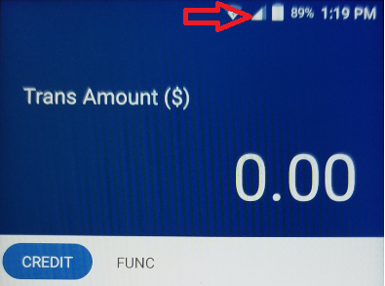

**If there is no Signal or service bars please check the following items:**

1. Confirm the client has an AT&T IOT SIM card. AT&T Business cellular SIM cards are not compatible- must be IOT SIM with AT&T. T-Mobile is supported at this time.
2. Confirm the SIM card is installed in the correct SIM card slot with chip side down.



1. Confirm Data Enable and Data Roaming are enabled. Confirm Use preferred APN is disabled. 